

MMM Papergames-Process Document

**Table of Contents**

1. Scope 2

2. Model Approach 3

3. Modeling Process 3

4. Output/Results: 7

# Scope

**KPI**

IAP Revenue scaled

Time Period: 184 days (1st May 2021 to 31st Oct 2021)

Granularity: Daily level data

**Model Measures**

Measures considered for the analysis are categorized into following groups:

* Base
* Calendar
  + Weekend/weekday Flag
  + Holiday
* Media
  + YouTube Impressions
  + Twitter Impressions
  + Facebook Impressions
  + Amoad Impressions
  + Nend Impressions
* Non-Media
  + Updates
  + Internal Events

# Model Approach

Started with the ‘IAP Revenue scaled.’ (KPI) using our platform Demand Drivers Edge (DDE). DDE runs statistical models by blending media, promotions, macro-economic indicators data and other bolt specific inputs required to quantify the relationship on KPI.

**KPI=Intercept+β1* Base+β2* Media+β3* Promo+....**

# Modeling Process

1. **Base** –
2. Started with base model by including Updates and internal events (Since there were no other base variables in the data provided, we started off these two)
3. Data Included are Update, Internal event
4. 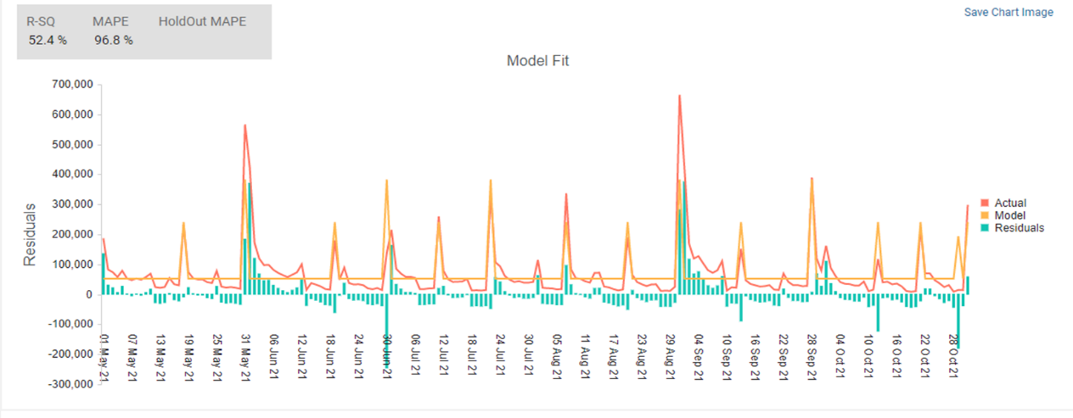Model Fit
5. Coefficients

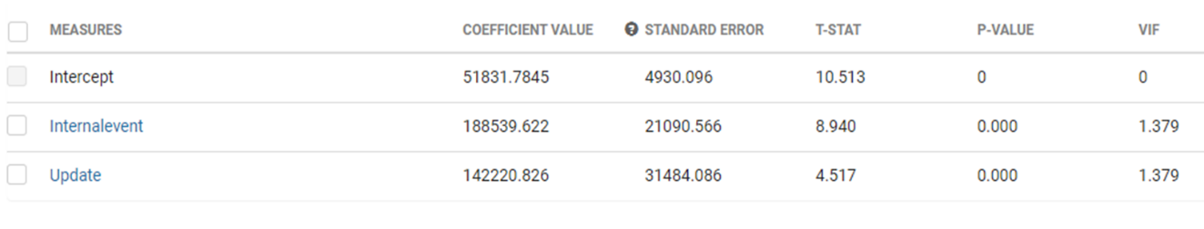

1. **Media –**
2. **Next included media (one variable at a time).** To test media, we considered spend share of media variables to identify the significant ones to begin with. Here from the below table YouTube shares the highest spend share of all the media factors.

|  |  |  |
| --- | --- | --- |
| Metric | Spend (000’) | Spend Share in % |
| YouTube | 2,992 | 55% |
| Twitter | 1,854 | 34% |
| Facebook | 253 | 5% |
| Amoad | 182 | 3% |
| Nend | 140 | 3% |

1. Hence, we started off with the raw media variables and initially we tested YouTube with splits basis the iOS 14.5 adoption rate in the model.

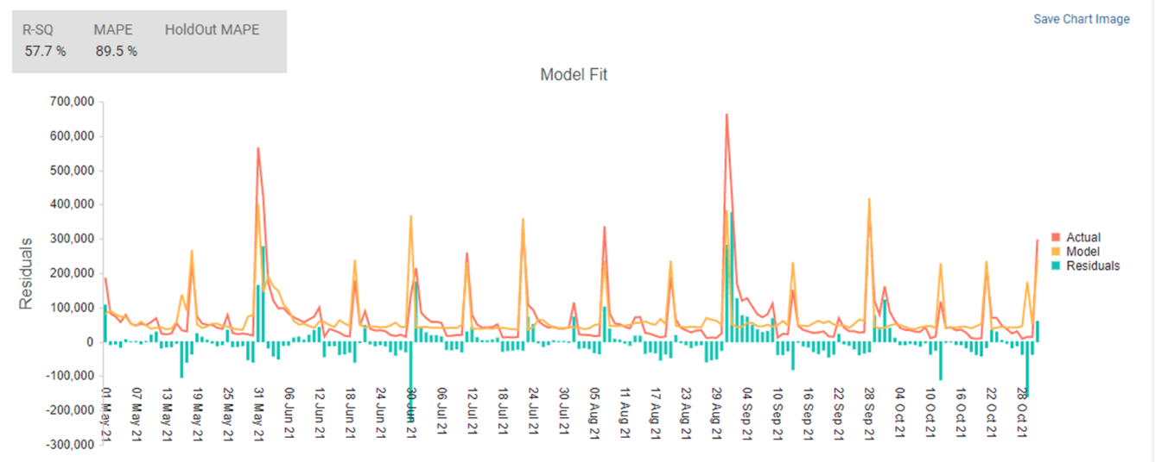

1. As stated, in order to capture the carryover impact of media variables suitable Transformations (Ad stock /Gamma) have been selected and parameters are identified by running multiple iterations and comparing model fits for each.
2. For ex : Below screenshot shows the different transformations applied for YT_Sep_Oct ; the first one has a better correlation with the KPI than the other two transformations and also goes better with the KPI trend and hence we will input YT_Sep_Oct_GM_Demo1 variable into the model. Similarly, we will follow the same for other media variables.

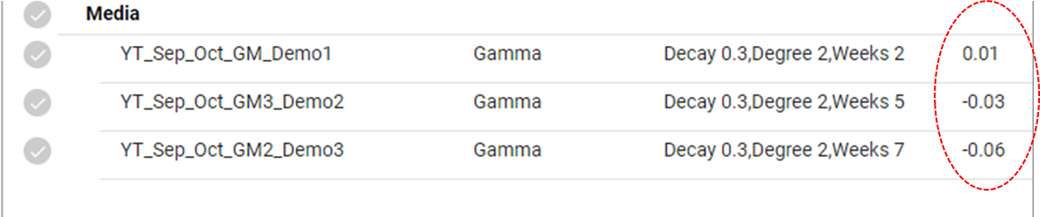

1. The chart below demonstrates how the model fit improved after adding the transformed YouTube variables rather than directly adding raw factors to the model

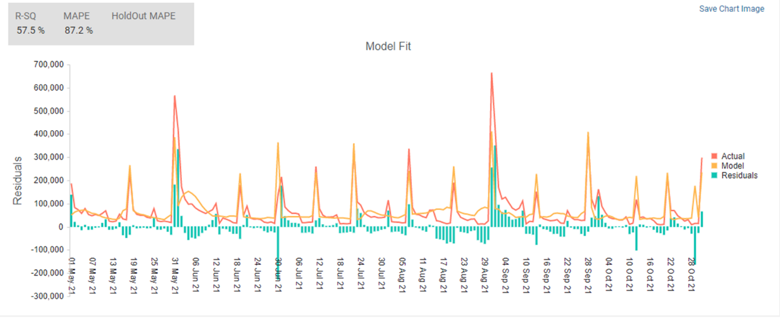

1. In a similar manner, we will add each of the transformed media variables (based on the expenditure share) one at a time and observe how the model reacts after doing so.

1. Following is list of media variables that we used in the model.

|  |  |  |
| --- | --- | --- |
| **Media** | Transformation used | Spend share (with in Media) |
| **Twitter/Facebook** | Gamma on impressions | Twitter (34%), Facebook (36%), Apple (4%) |
| **Amoad/Nend** | Gamma on impressions | Amoad (3%), Nend (3%)) |

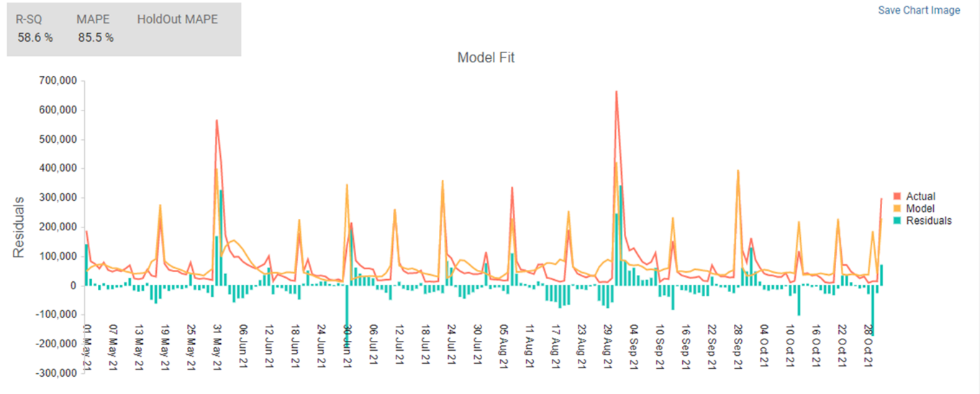

Model Fit After adding some of the media variables

1. For each media, multiple iterations are run and tracked how the above-mentioned metrics are varying.

Coefficient for above run iteration

1. The majority of the media variables in the aforementioned iterations have picked up the +ve coefficients; therefore, let's use them as Prior and give each variable a standard deviation ranging from 10% to 30%.

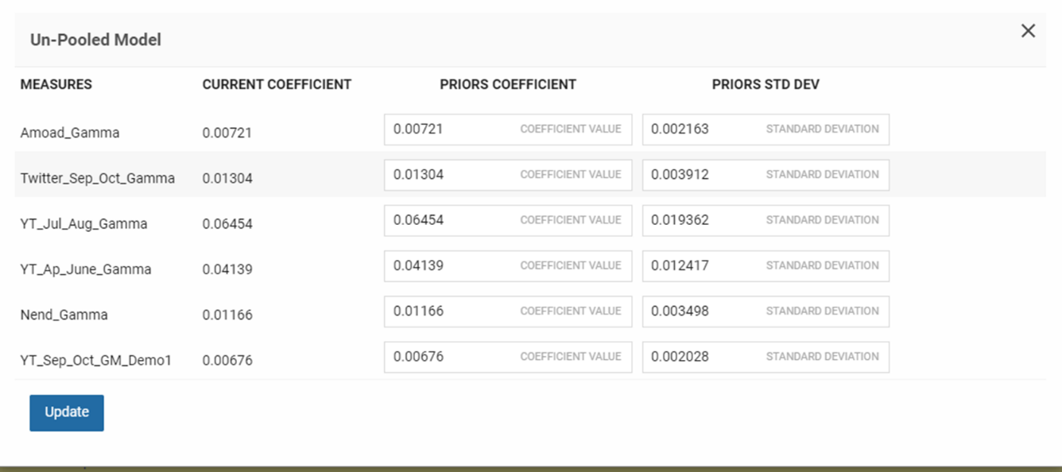

1. Once priors are incorporated model stability has been validated through statistical diagnostics for each iteration to ensure overall model fit is intact
2. Based on these iterations and range of coefficients / contributions are tracked for media variables.

Period 1 here refer to the Total Modelling period

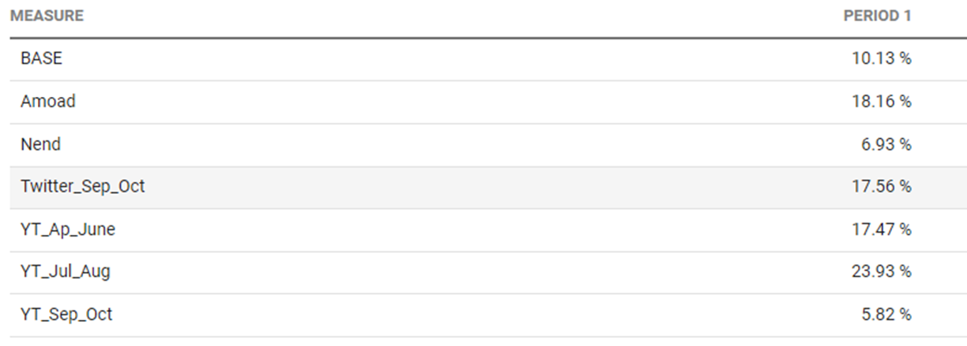

1. **Non-Media –**

|  |  |
| --- | --- |
| **Type** | **Values** |
| Updates | 1’s When update occurred; otherwise, 0 |
| Events | 1’s When events occurred; otherwise, 0 |
| Bugfix | 1’s When bugfix occurred; otherwise, 0 |

1. Updates:

Since the model fit is still not ideal let’s split the update variables and see how the model fit improves or changes

We have applied the exponential transformations just to accurately capture the peaks.

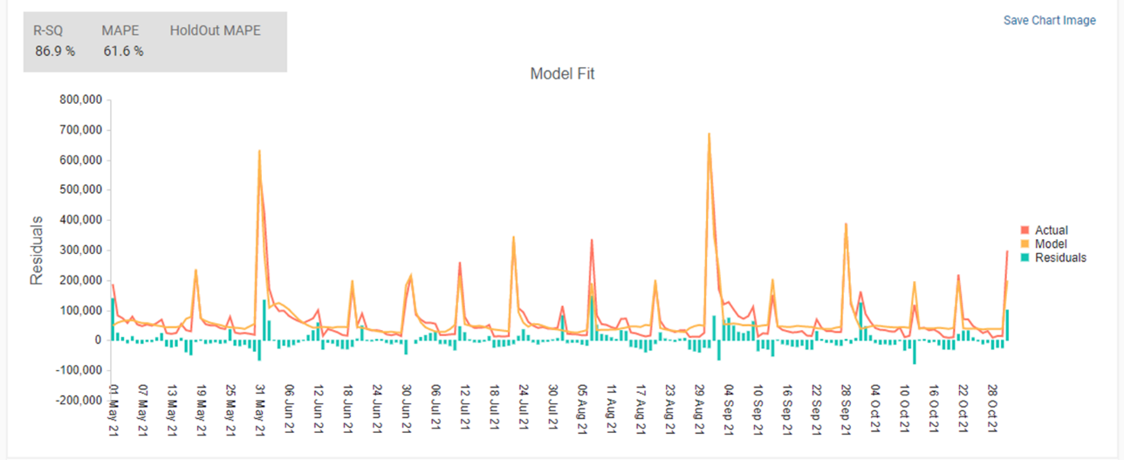

1. Events/BugFixes:

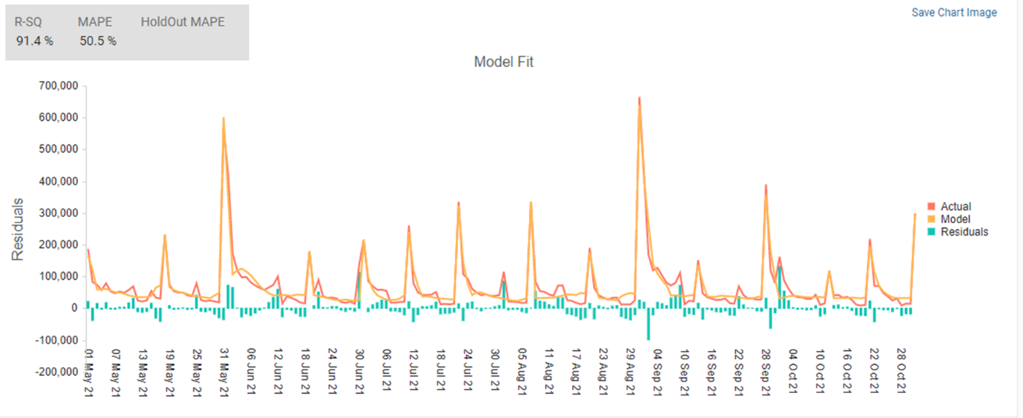

Model Fit after splitting the internal events

1. In order to better capture the dips/peaks, let’s also introduce some of post updates dummies in the model.

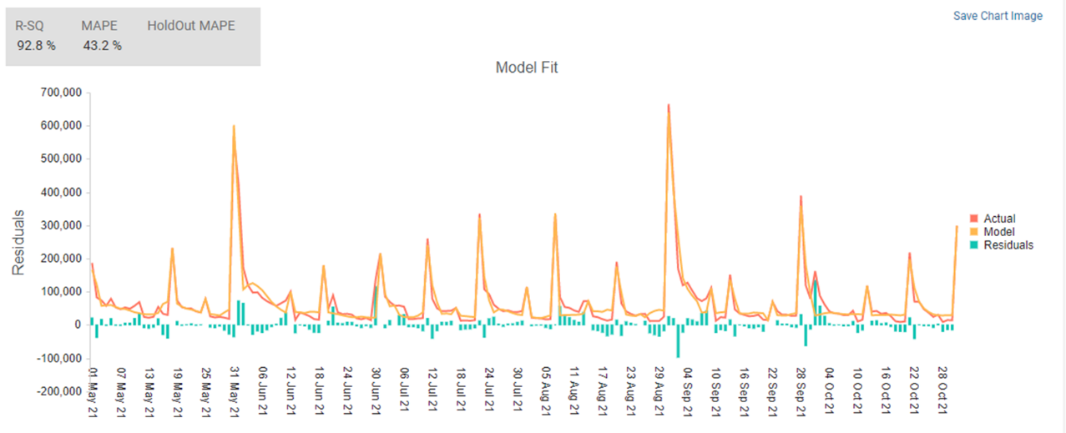

1. Finally, to further improve the model we have introduced holidays and some seasonality dummies

# Output/Results:

1. **Model Fits – IAP Revenue scaled** -- The model was developed on data from 1st May’21 – 31st Oct’21 and the resulting model fit is robust based on statistical diagnostics.

As we have huge variations in the KPI, we have used “Weighted MAPE” to capture the % error rather than calculating Avg MAPE.

Avg MAPE = Abs((Actual-Predicted)/Actual) *100

Weighted MAPE = Sum product (Daily Avg MAPE, KPI)/Sum(KPI)

1. **Contribution** – Given the current levels of execution what is the individual contribution of each media/promotion.

